**FACE DETECTION APP CREATION USING AWS**

**AWS LOGIN SCREEN WITH USERNAME :**

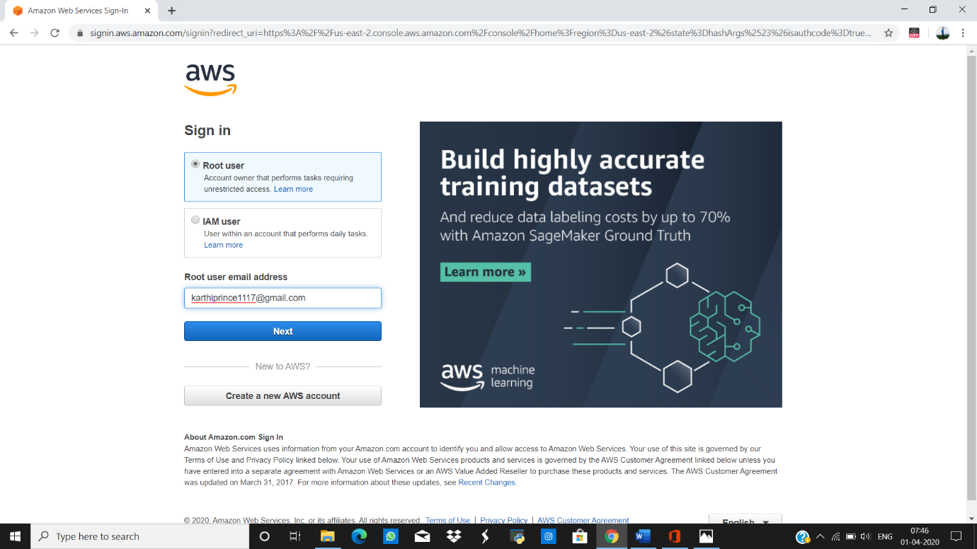

**AWS HOME PAGE :**

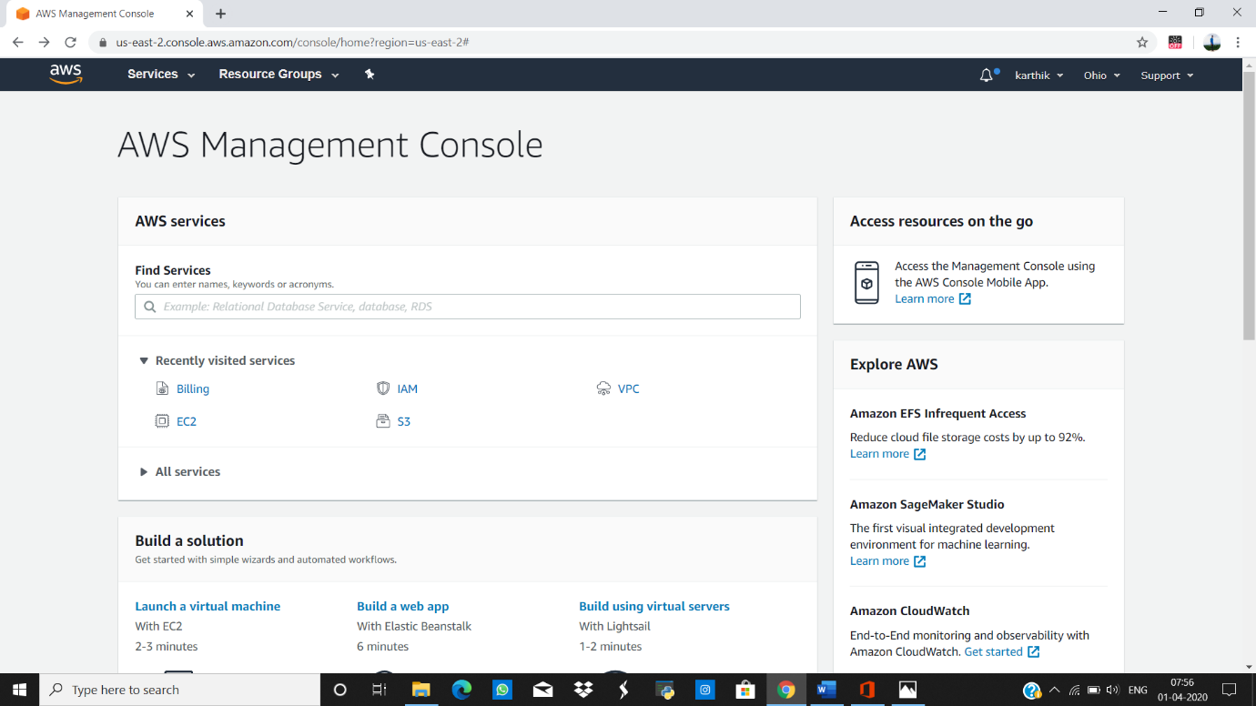

**EC2 DASHBOARD :**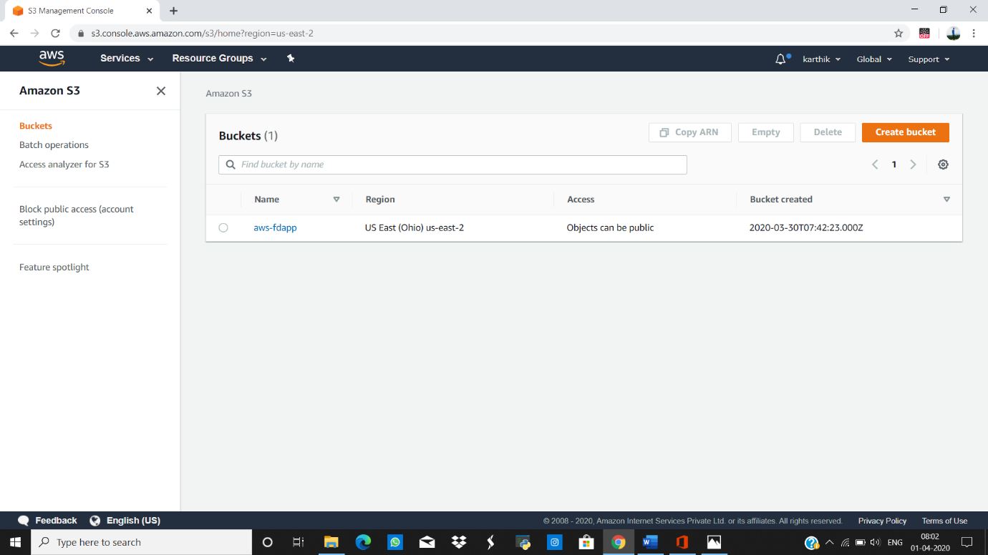

**S3 DASHBOARD :**



**REKOGNITION DASHBOARD :**

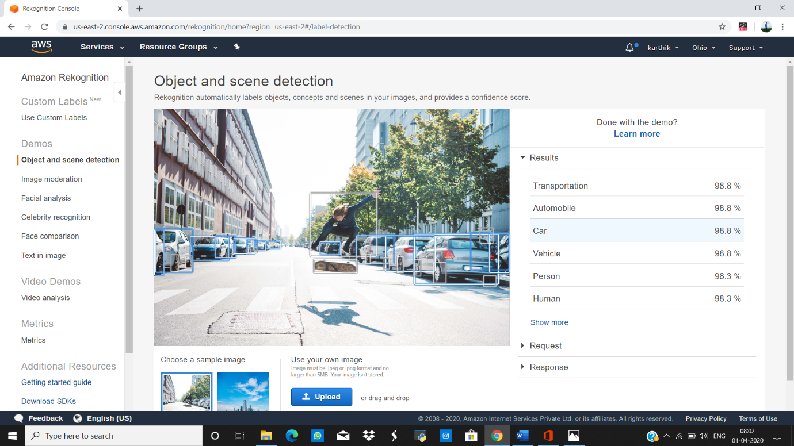

**EC2(ELASTIC CLOUD COMPUTE)**

**Choosing an AMI :**

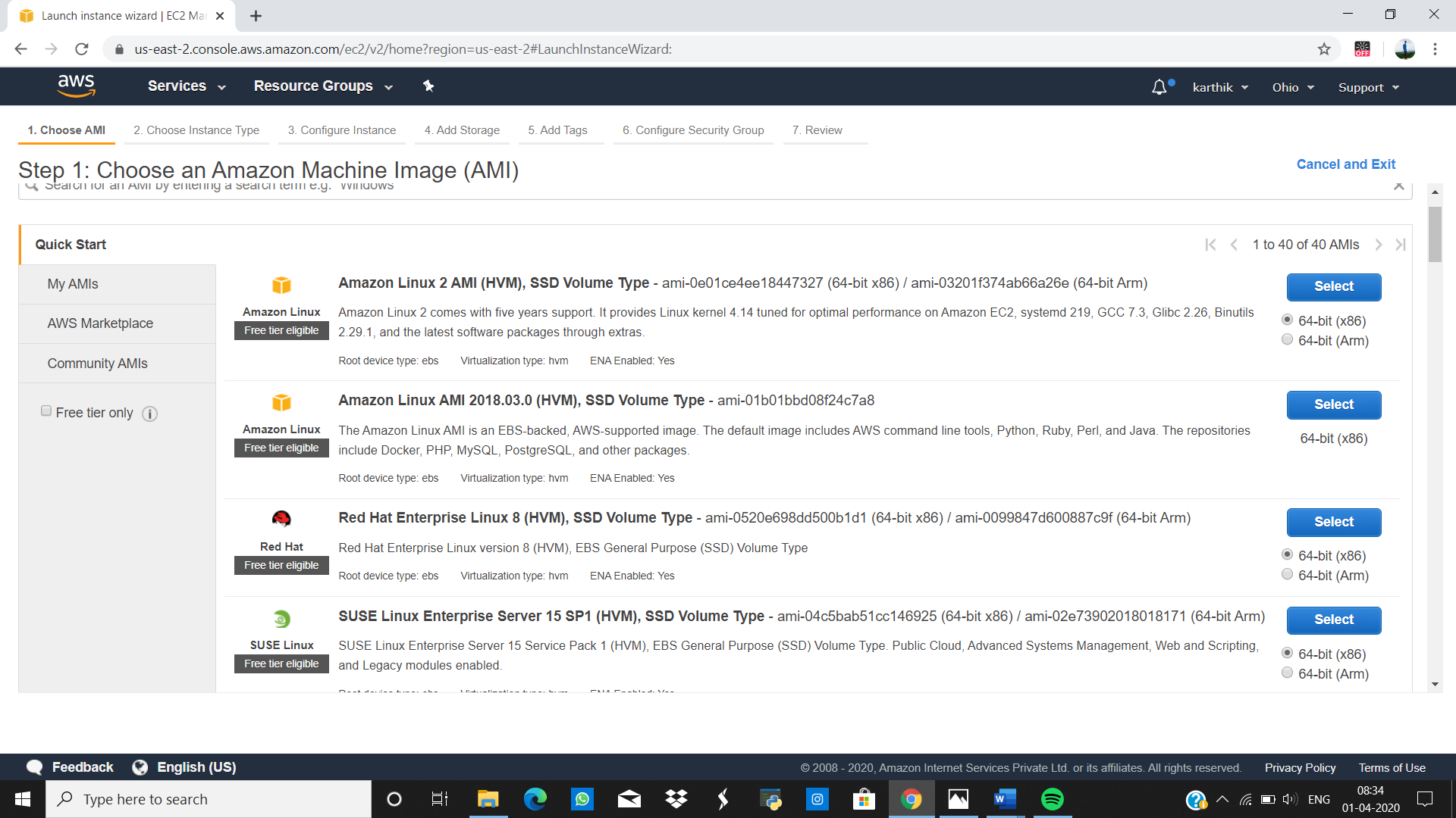

**CHOOSING AN INSTANCE TYPE :**

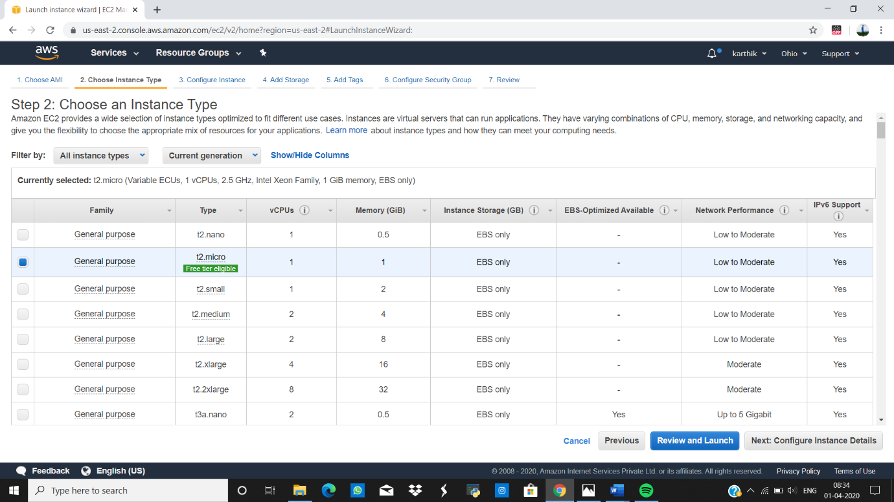

**ADDING STORAGE :**

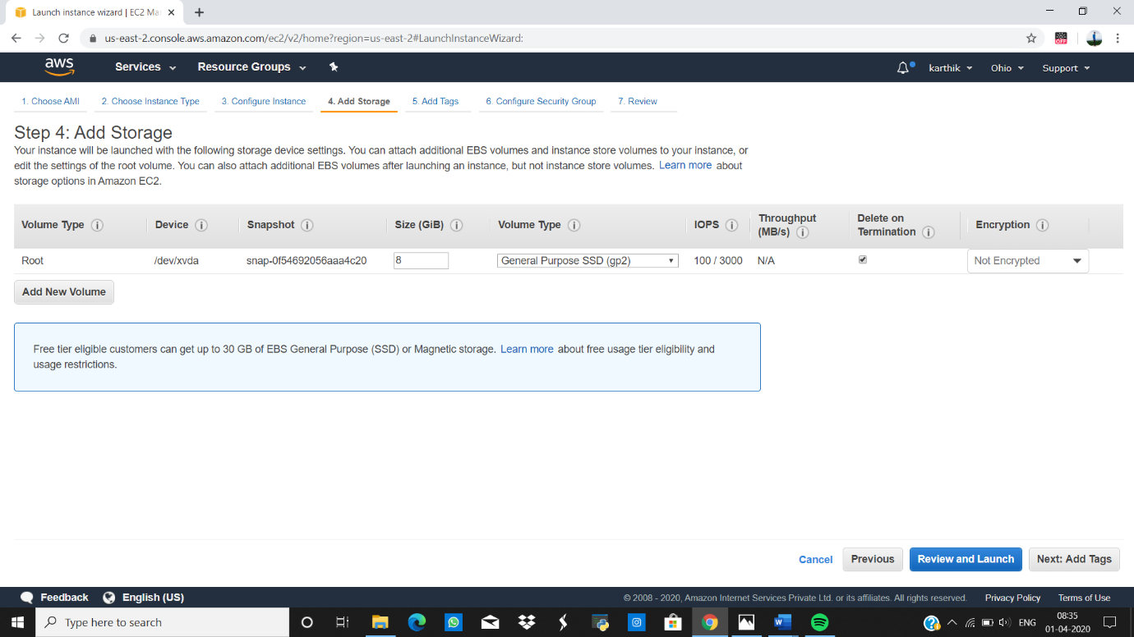

**CONFIGURING SECURITY GROUP :**

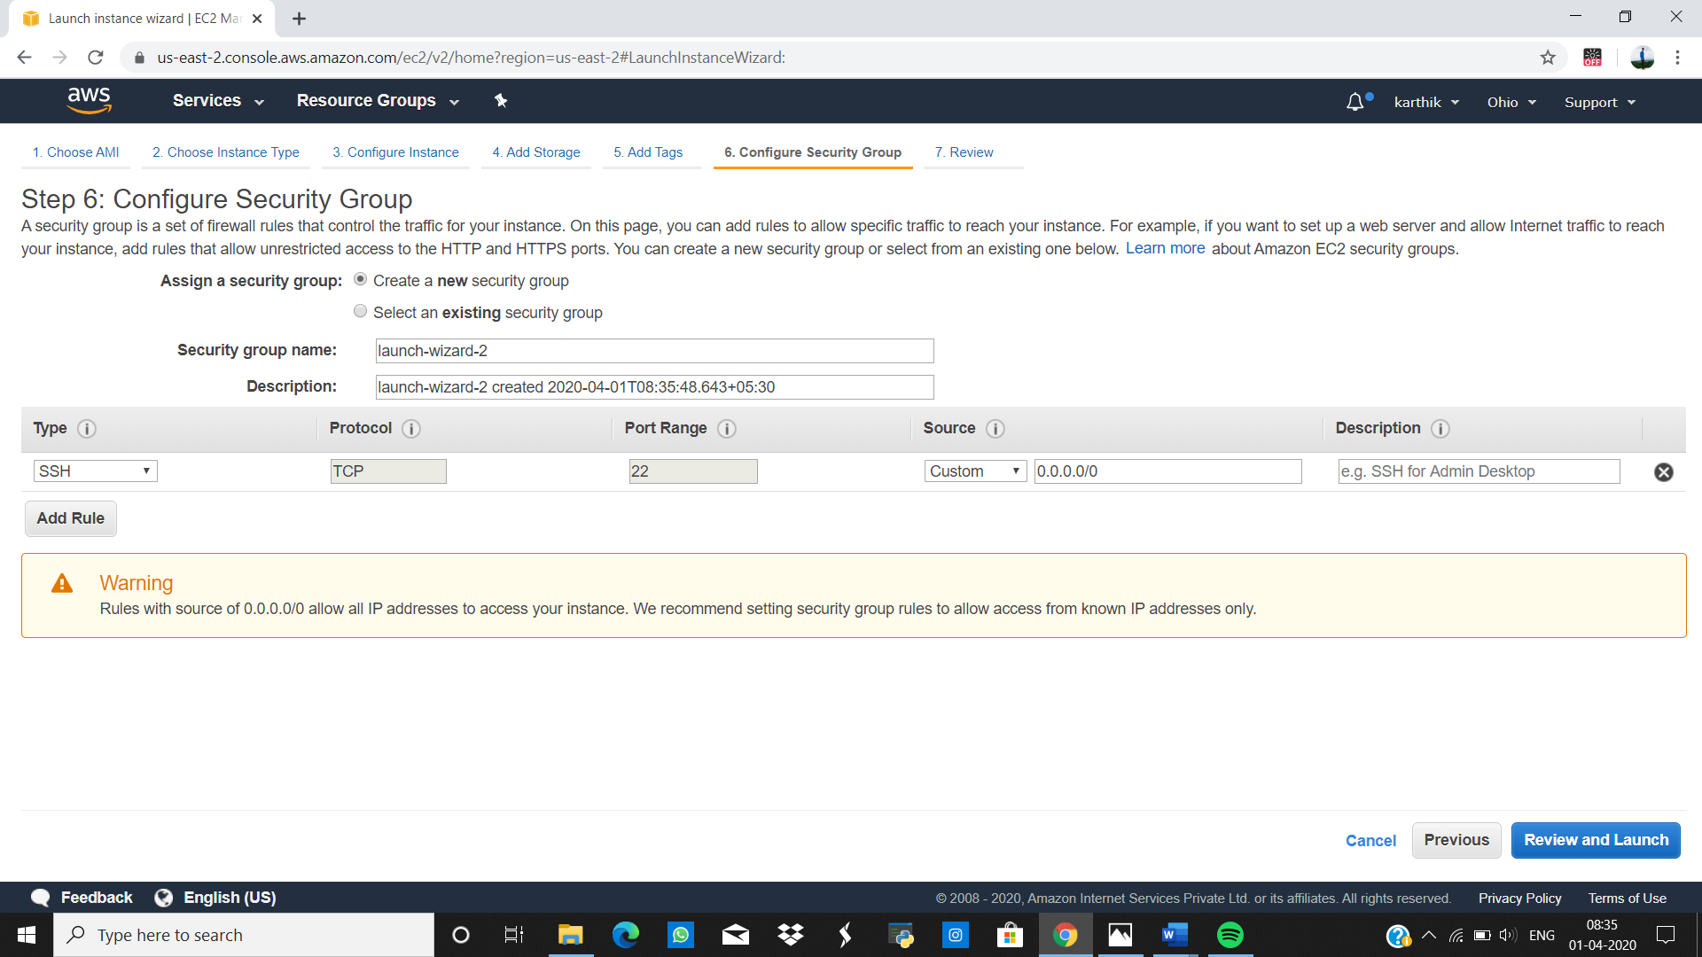

**KEY PAIR DOWNLOAD :**

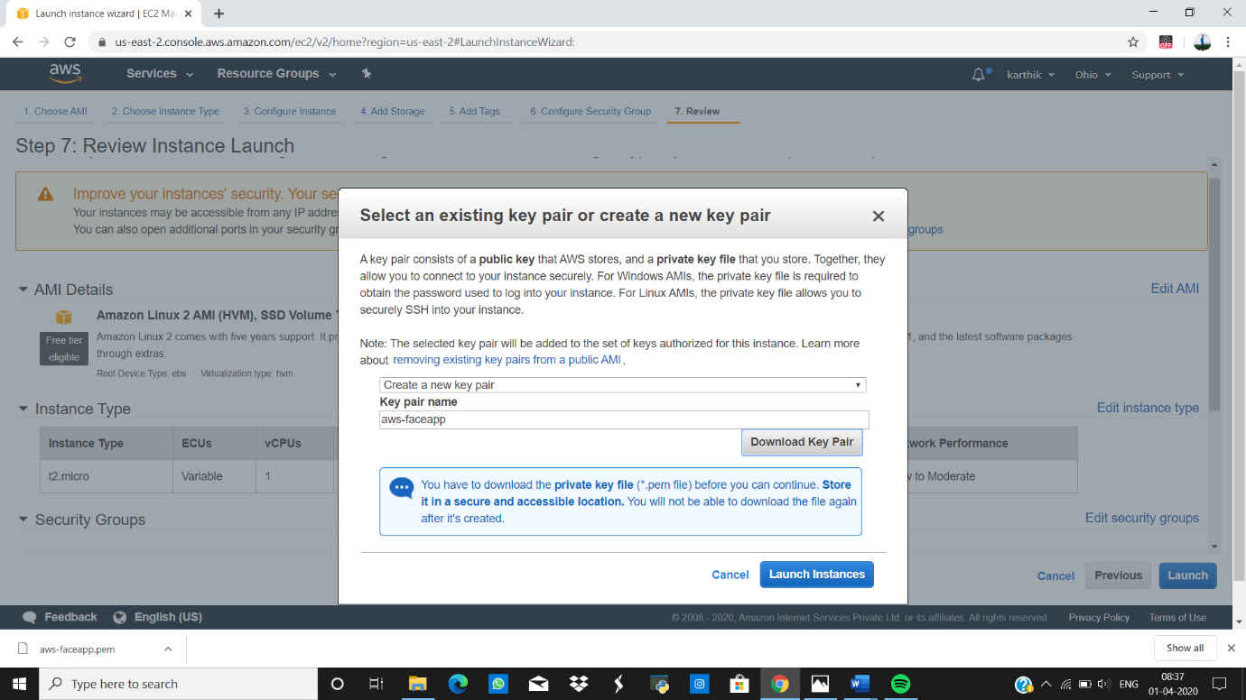

**PUTTYGEN CONVERSION FROM PEM TO PPK :**

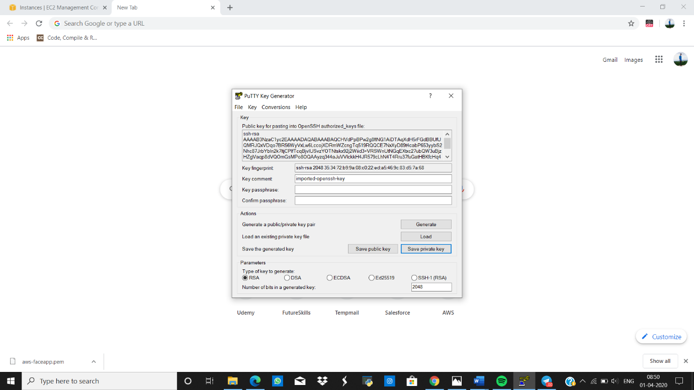

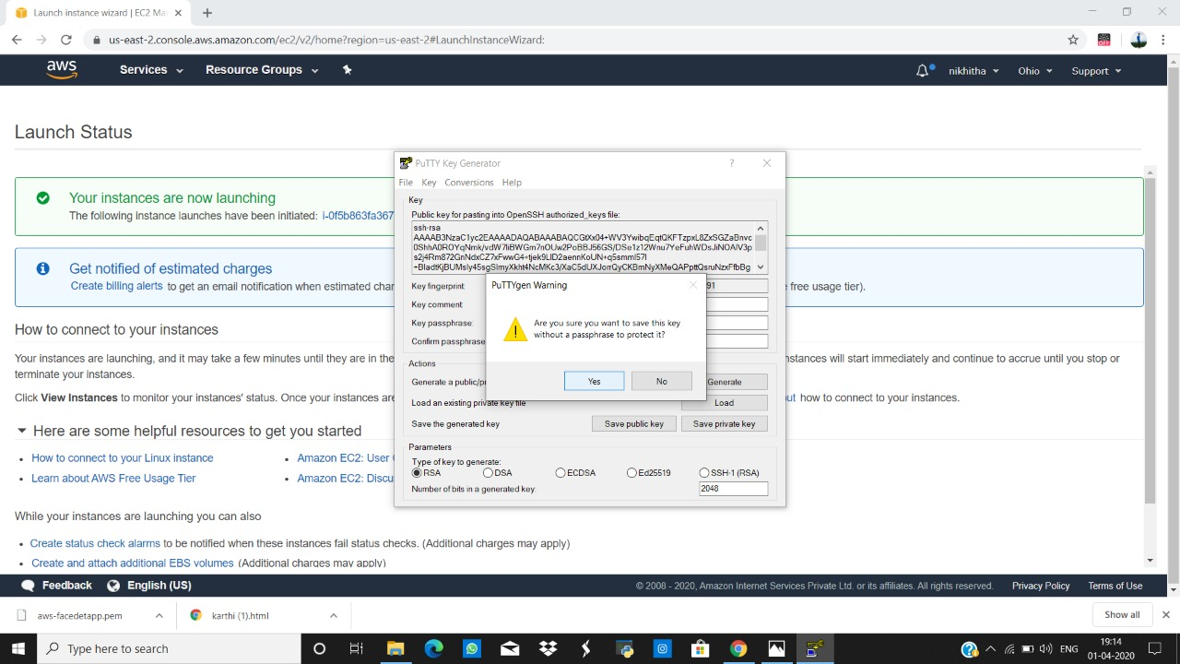

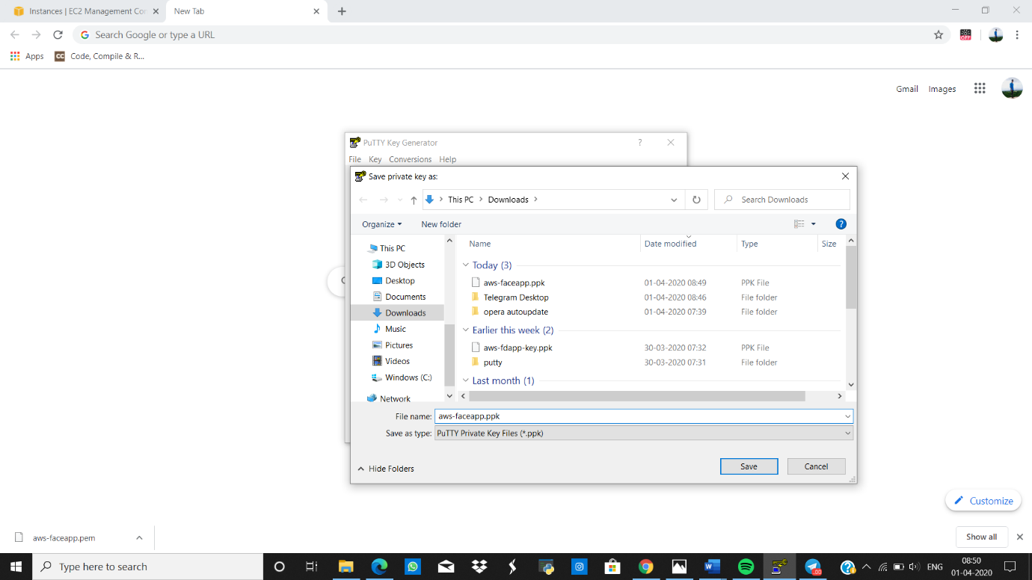

**LOOGED IN EC2 BLACSCREEN :**

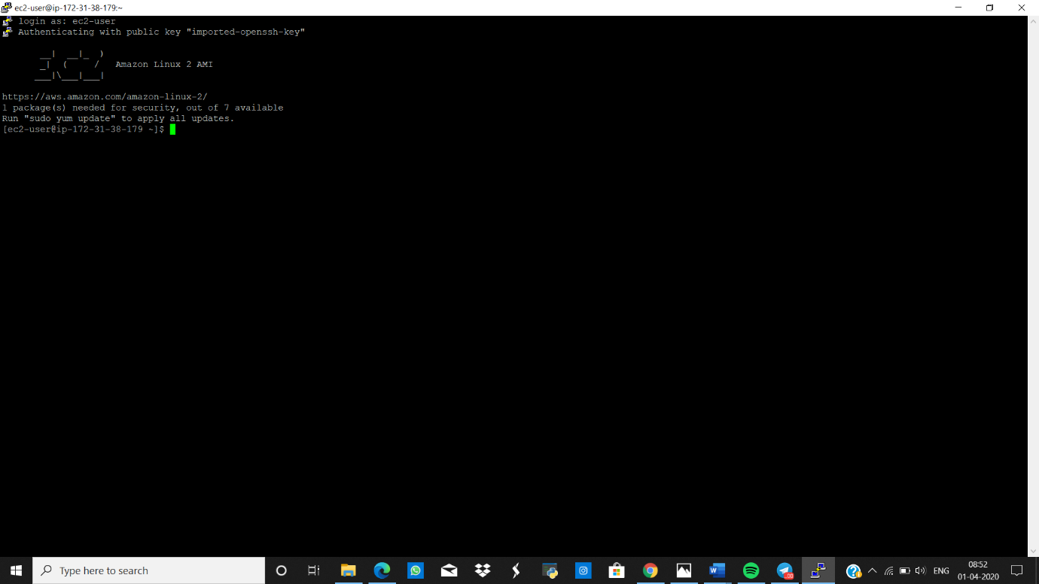

**S3(SIMPLE STORAGE SERVICE)**

**CREATING A BUCKET :**

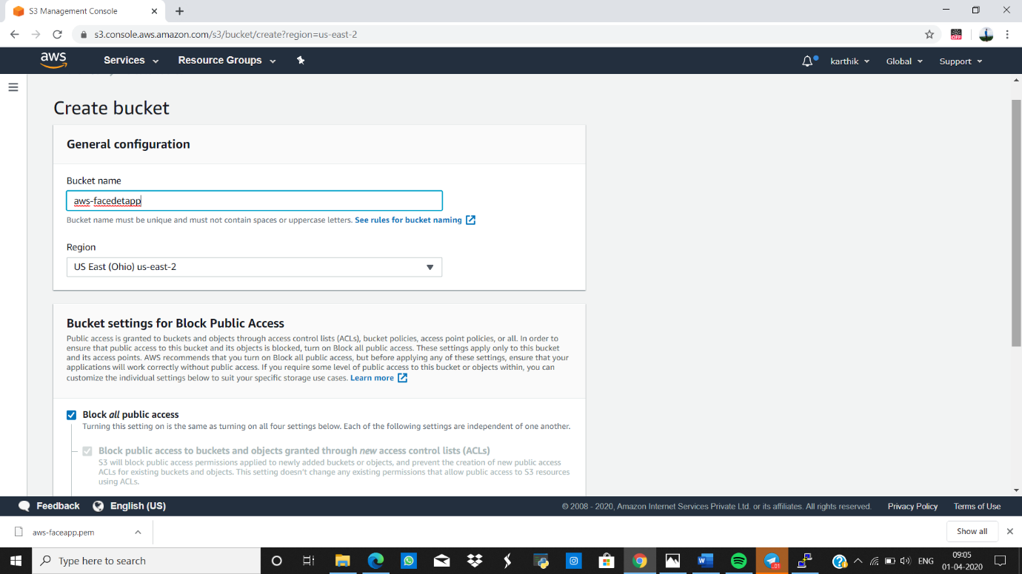

**UPLOADING AN OBJECT :**

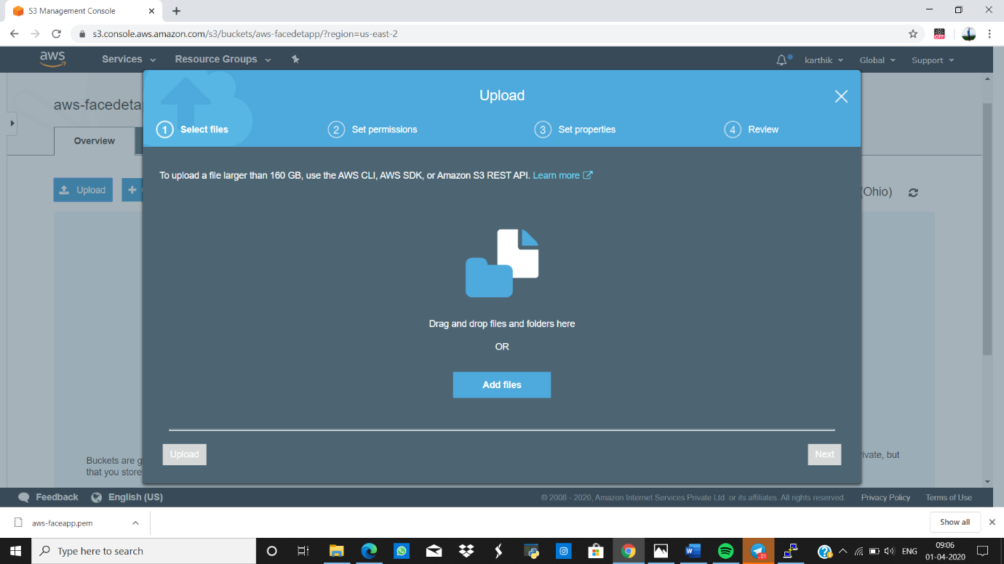

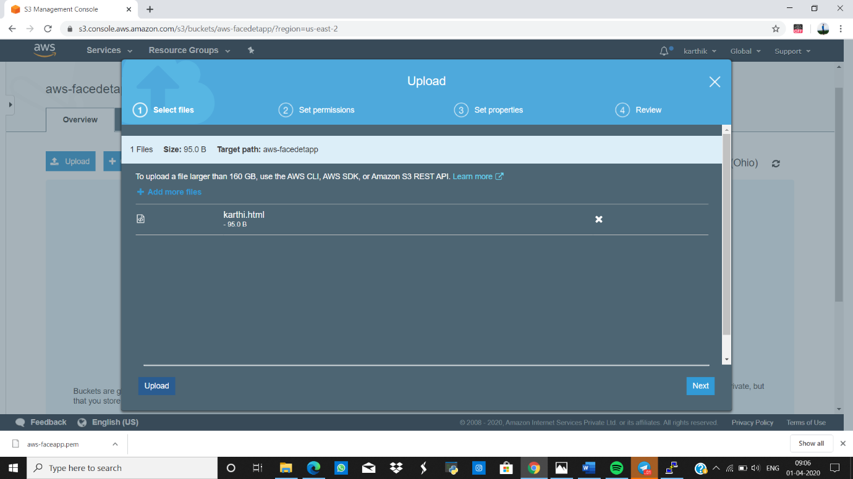

**ENABLIC STATIC WEBSITE :**

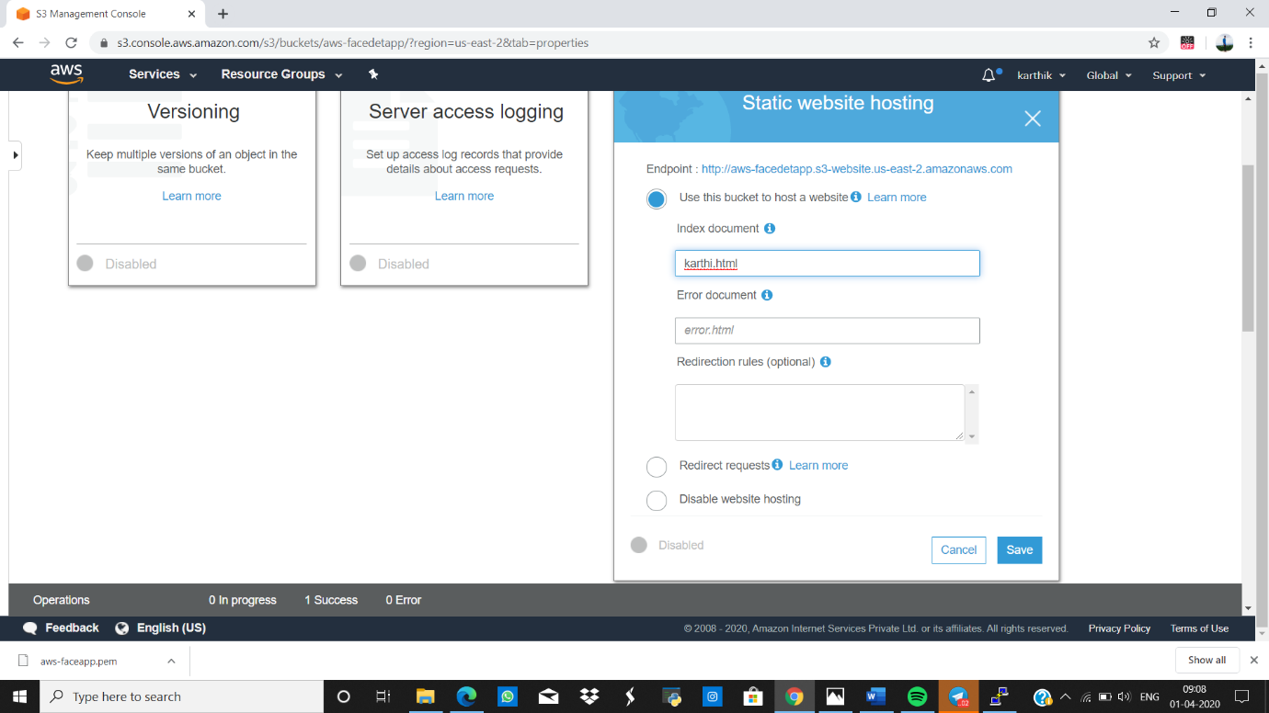

**MAKING THE OBJECT PUBLIC :**

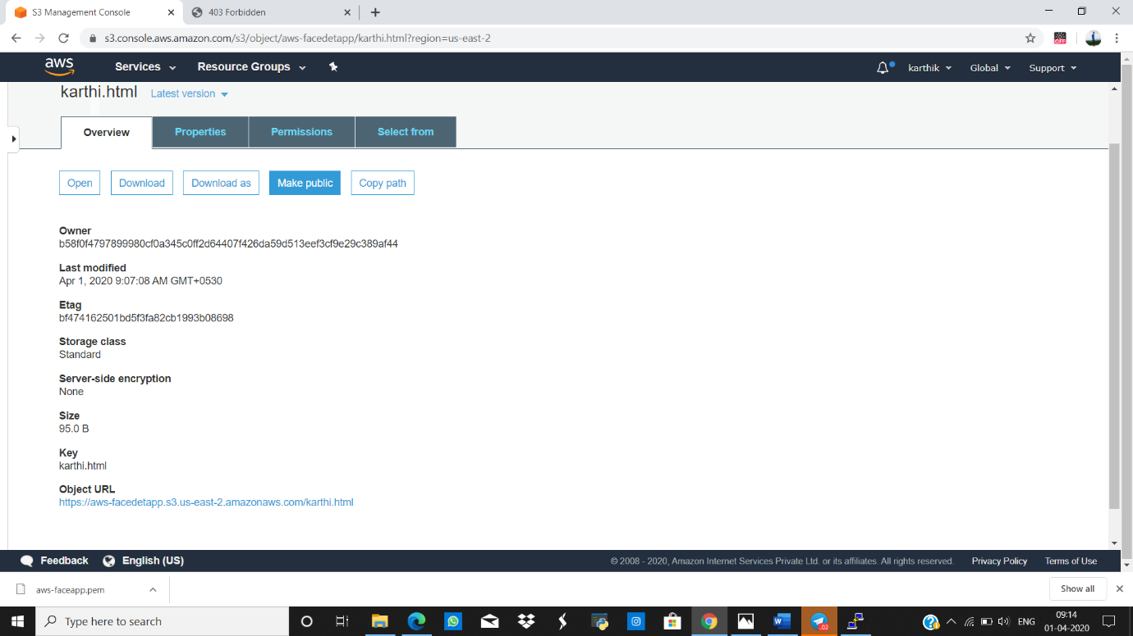

**UNBLOCK ALL PUBLIC ACCESS :**

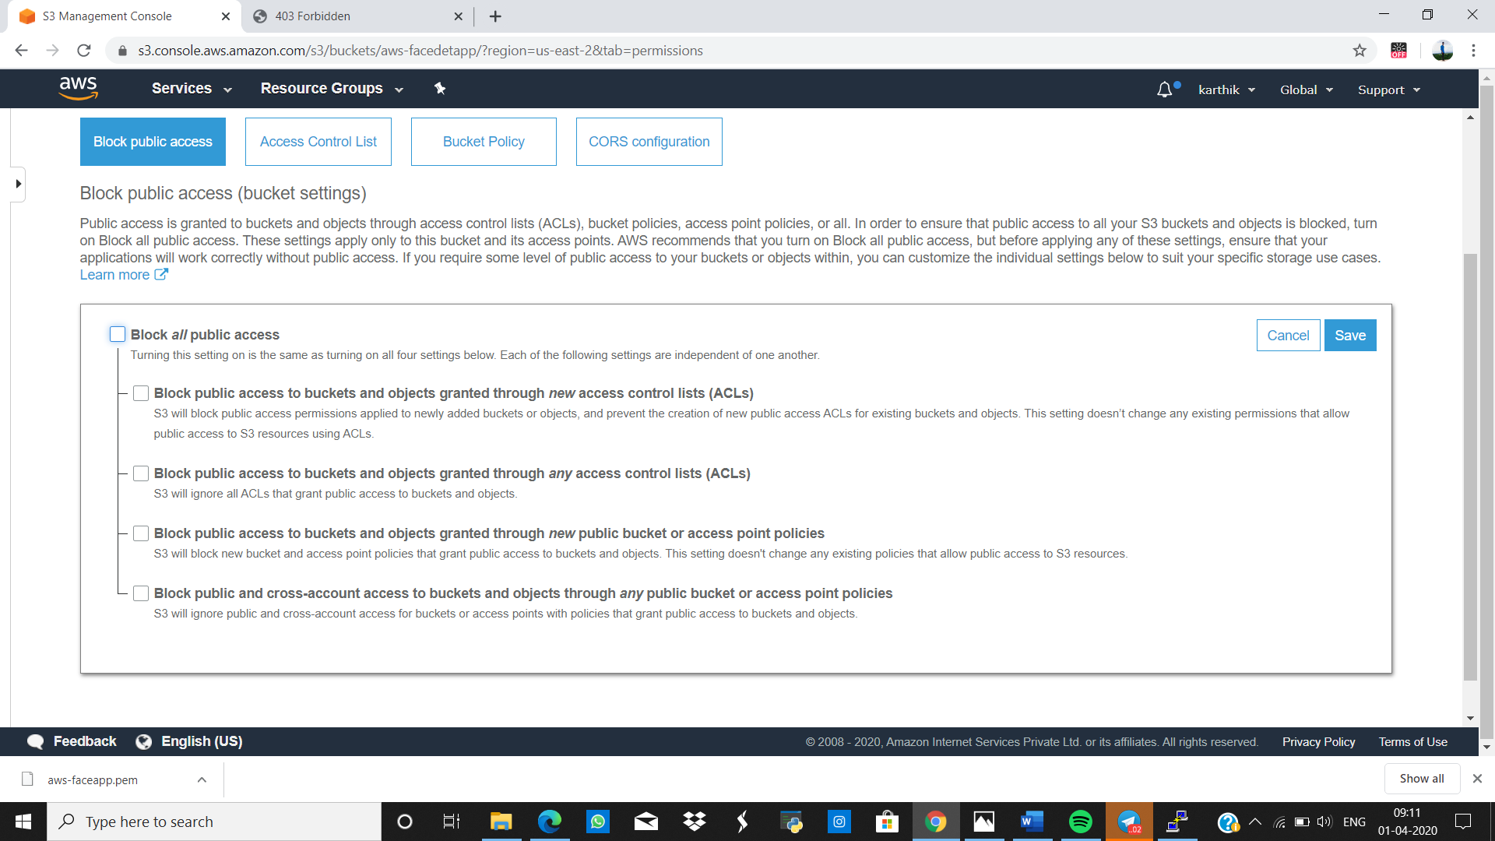

**CHECKING THE S3 LINK ON THE BROWSER :**

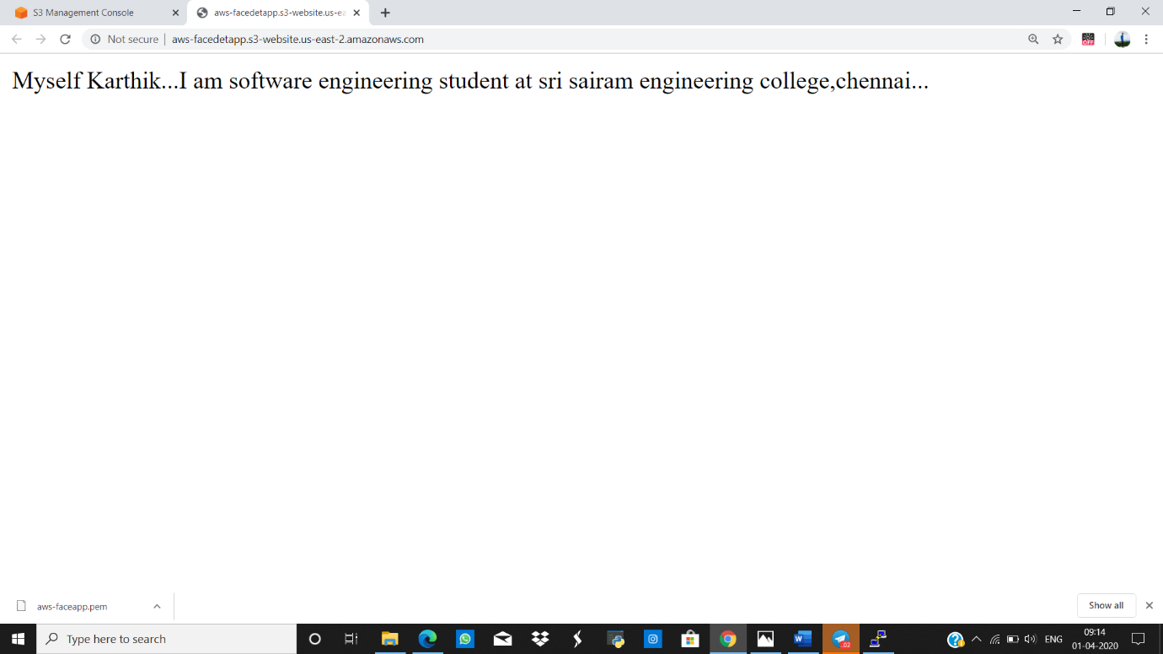

**REKOGNITION**

**FACE DETECT :**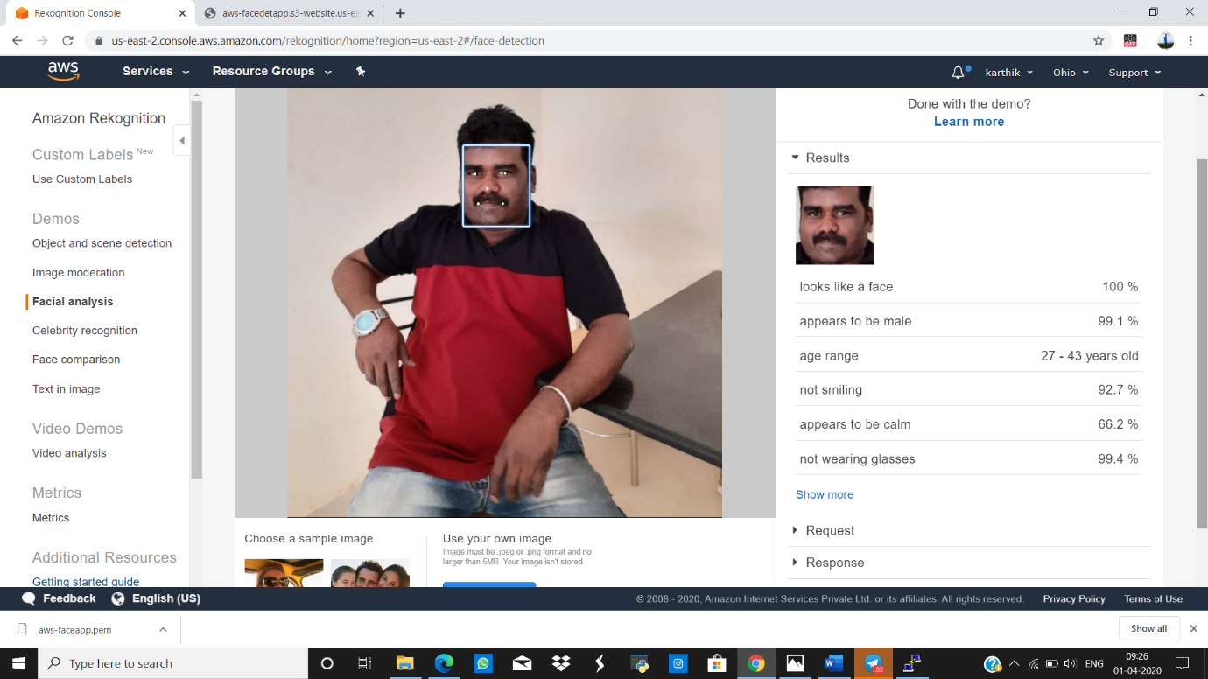

**FACE COMPARE :**

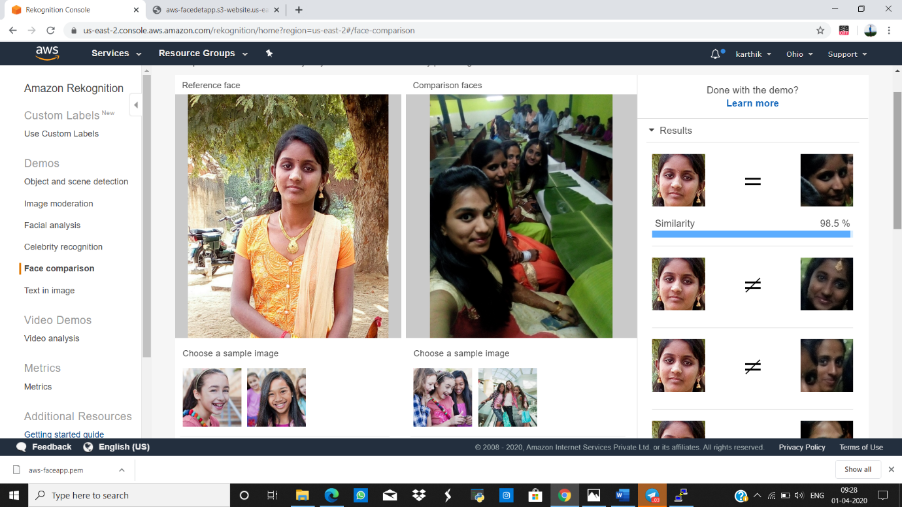

**CELEBRITY RECOGNITION :**

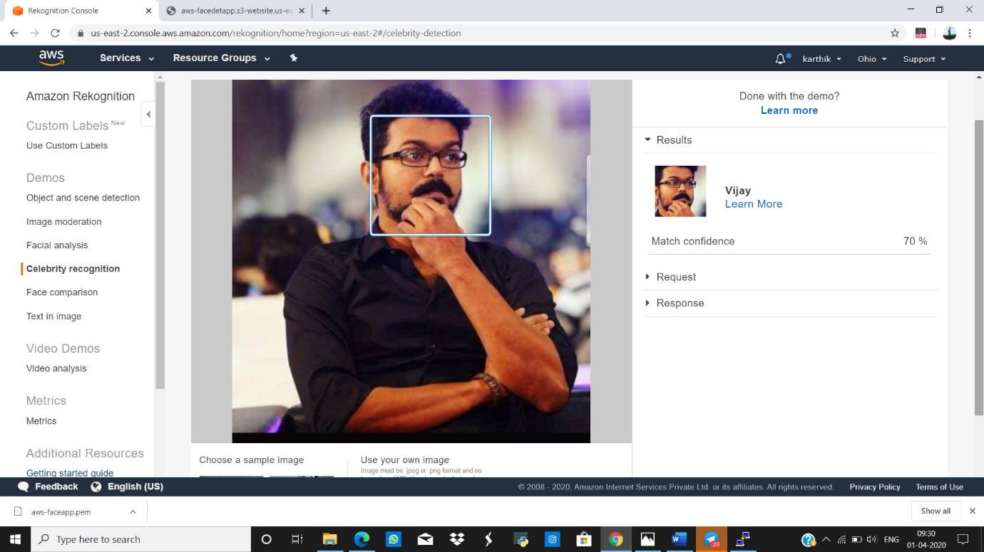

**TEXT IN IMAGE :**

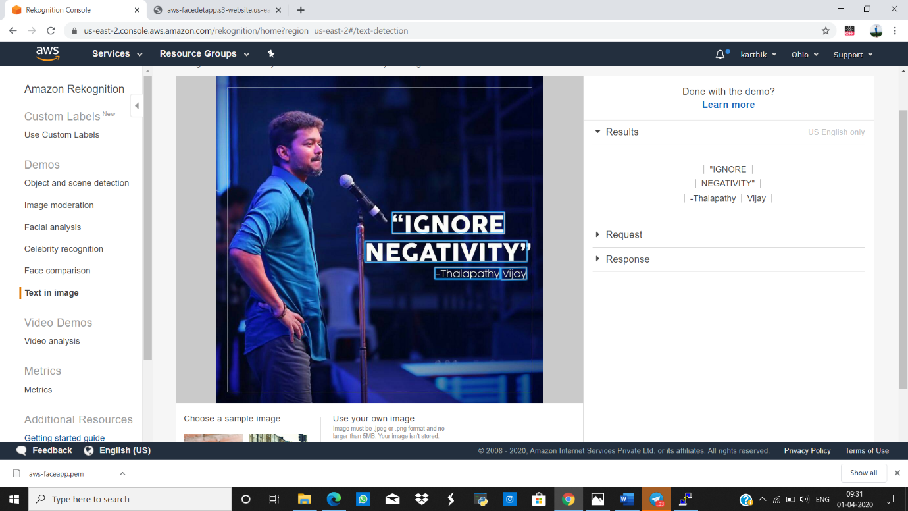

**EC2 AND S3**

**INSTALLING AWS-SDK**

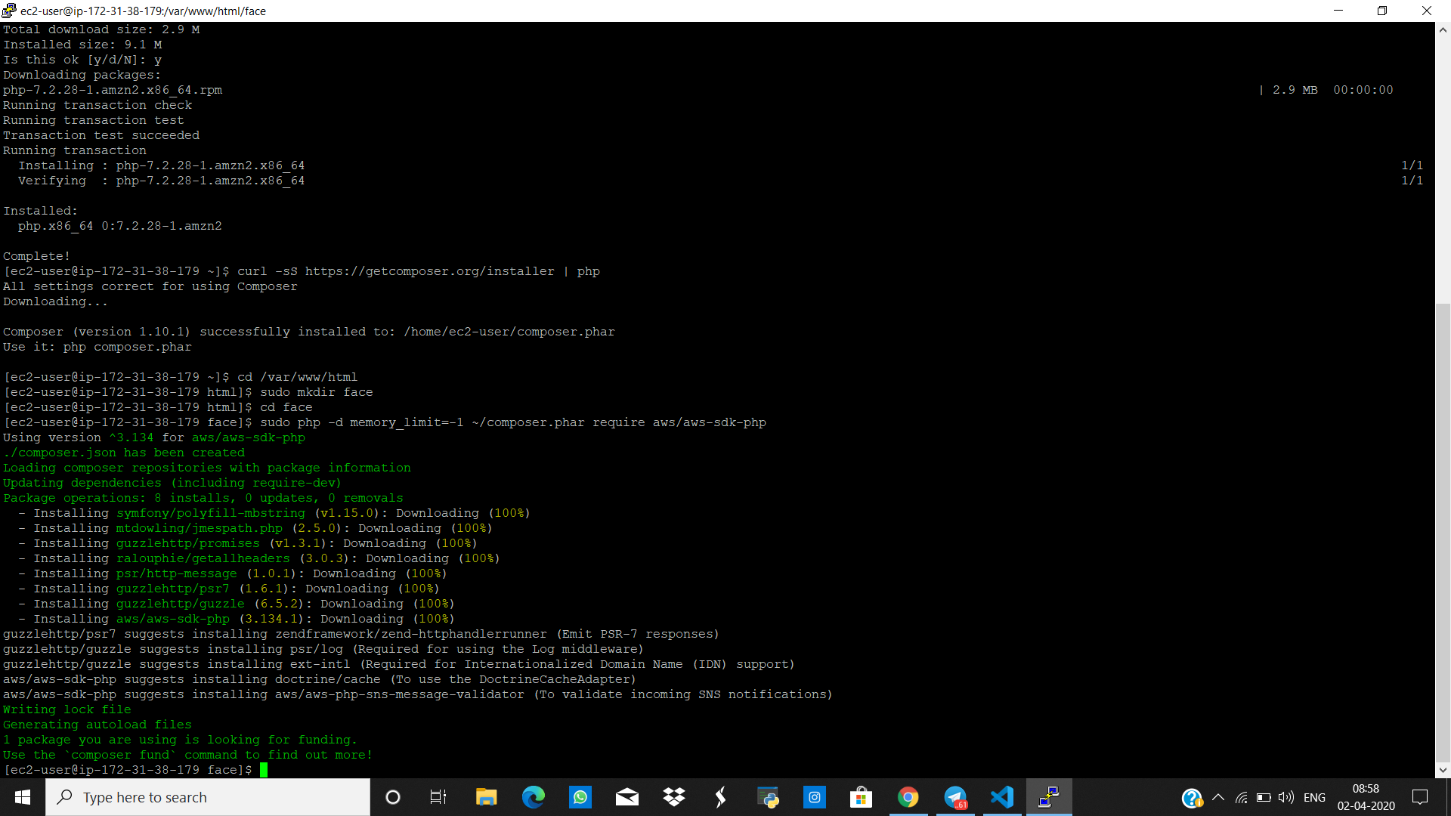

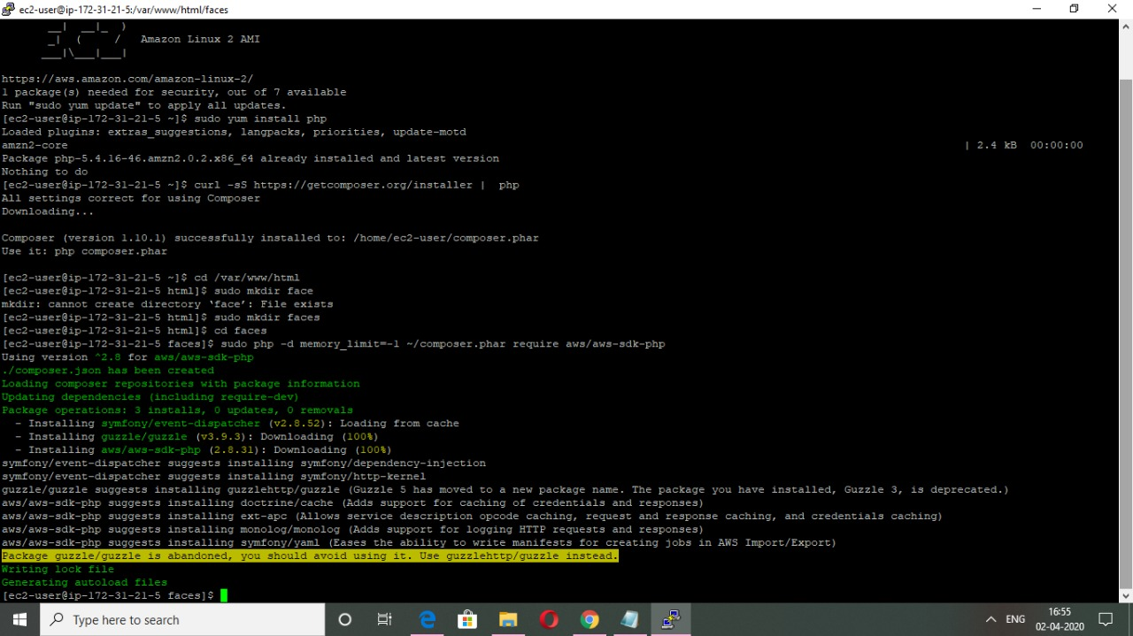

**INSTALLING PHP**

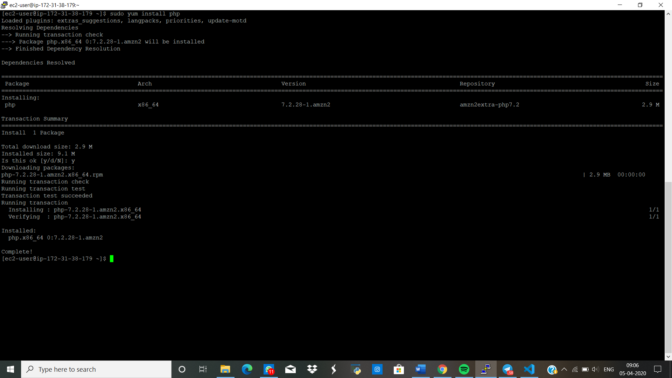

**PHP COMPOSER INSTALLATION**

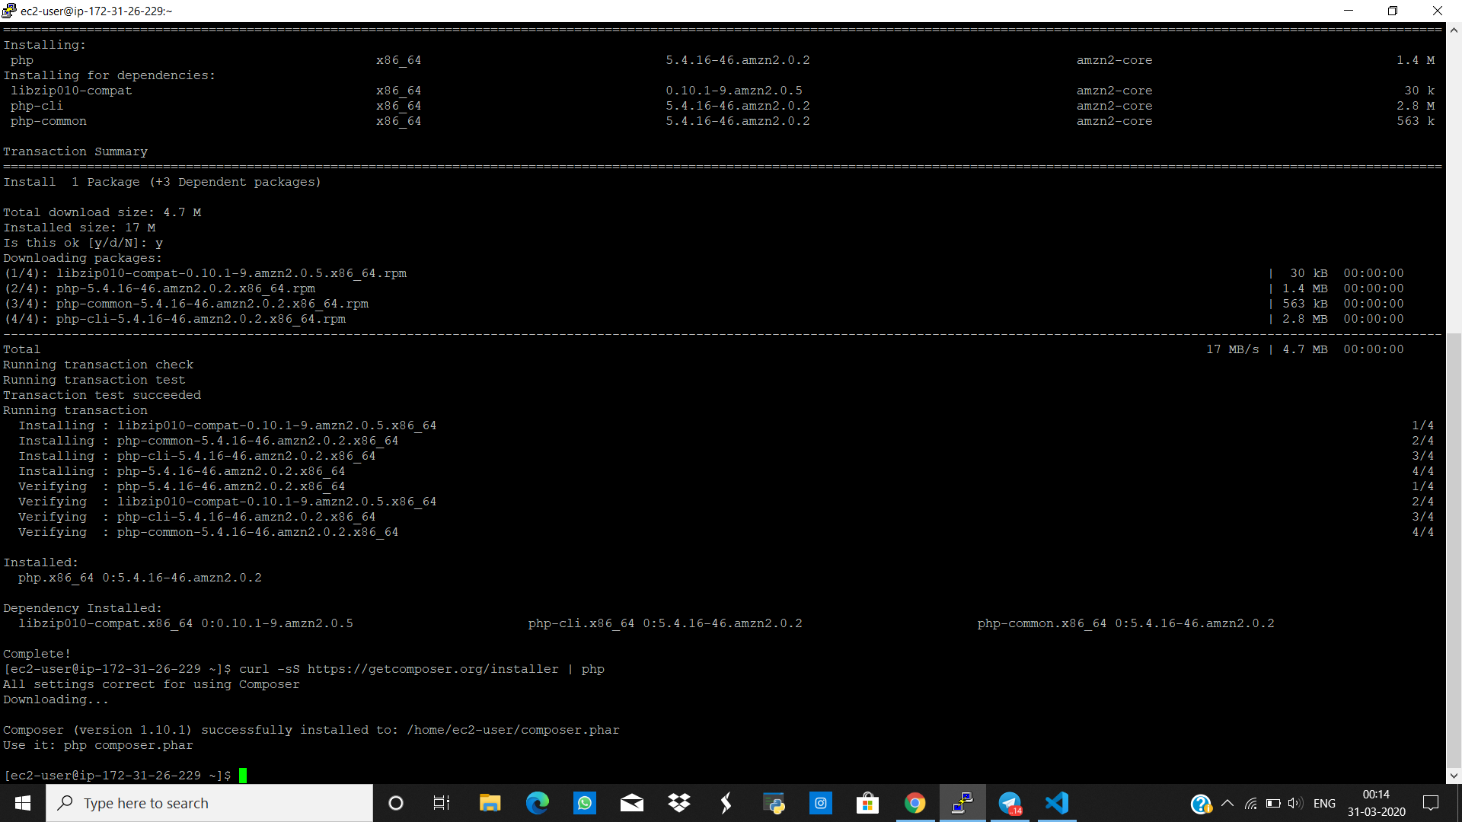

**INDEX.PHP FILE CODE**

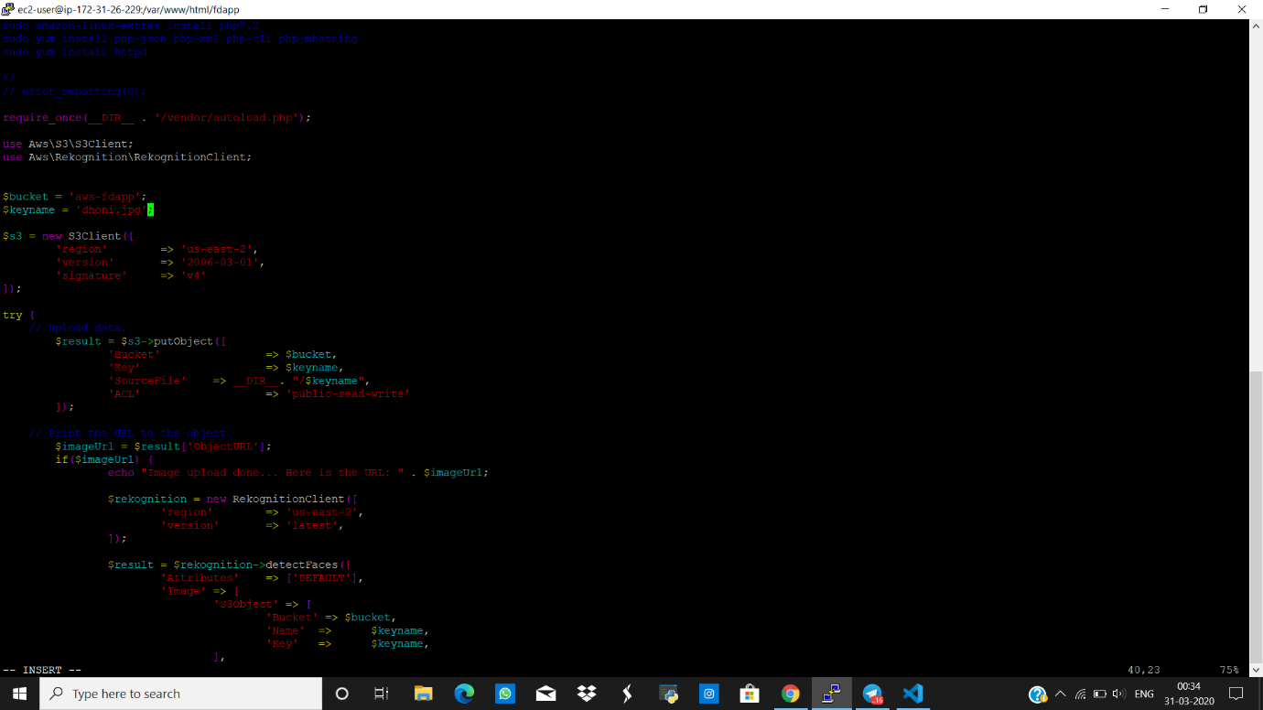

**UPLOAD SUCCESS SCREENSHOT**

